Lab - Using Wireshark to Observe the TCP 3-Way Handshake (Instructor Version)

**Instructor Note**: Red font color or gray highlights indicate text that appears in the instructor copy only.

1. Topology

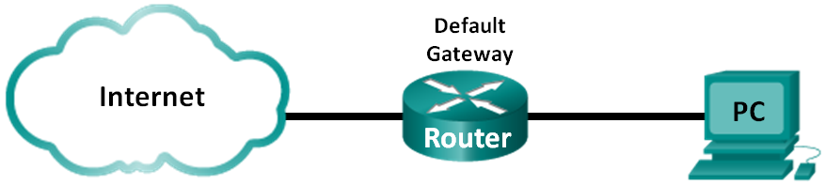

1. Objectives

Part 1: Prepare Wireshark to Capture Packets

Part 2: Capture, Locate, and Examine Packets

1. Background / Scenario

In this lab, you will use Wireshark to capture and examine packets generated between the PC browser using the HyperText Transfer Protocol (HTTP) and a web server, such as [www.google.com](http://www.google.com). When an application, such as HTTP or FTP (File Transfer Protocol) first starts on a host, TCP uses the three-way handshake to establish a reliable TCP session between the two hosts. For example, when a PC uses a web browser to surf the internet, a three-way handshake is initiated, and a session is established between the PC host and web server. A PC can have multiple, simultaneous, active TCP sessions with various websites.

**Note**: This lab cannot be completed using Netlab. This lab assumes that you have internet access.

**Instructor Note**: Using a packet sniffer, such as Wireshark, may be considered a breach of the security policy of the school. It is recommended that permission be obtained before running Wireshark for this lab. If using a packet sniffer is an issue, the instructor may wish to assign the lab as homework or perform a walk-through demonstration.

1. Required Resources

1 PC (Windows 7, 8, or 10 with a command prompt access, internet access, and Wireshark installed)

1. Prepare Wireshark to Capture Packets

In Part 1, you will start the Wireshark program and select the appropriate interface to begin capturing packets.

* 1. Retrieve the PC interface addresses.

For this lab, you need to retrieve the IP address of your PC and its network interface card (NIC) physical address, also called the MAC address.

* + 1. Open a command prompt window, type **ipconfig /all**, and press Enter.

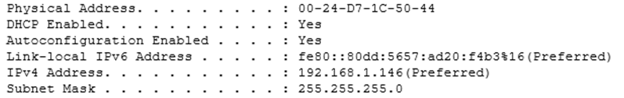

* + 1. Write down the IP and MAC addresses associated with the selected Ethernet adapter. That is the source address to look for when examining captured packets.

The PC host IP address: ____________________________________________________________

192.168.1.146.

The PC host MAC address: __________________________________________________________

00:24:D7:1C:50:44.

* 1. Start Wireshark and select the appropriate interface.
     1. Click the Windows **Start** button. In the pop-up menu, double-click **Wireshark**.
     2. After Wireshark starts, select the active interface for data capture. The active interface will show traffic activities.

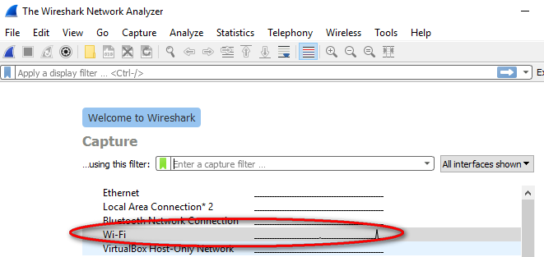

1. Capture, Locate, and Examine Packets
   1. Capture the data.
      1. Click the **Start** button to start the data capture.

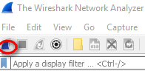

* + 1. Open a web browser and visit www.google.com.
    2. Minimize the browser and return to Wireshark. Stop the data capture.

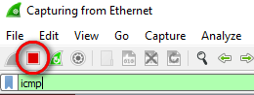

**Note**: Your instructor may provide you with a different website. If so, enter the website name or address here:

____________________________________________________________________________________

The capture window is now active. Locate the **Source**, **Destination**, and **Protocol** columns.

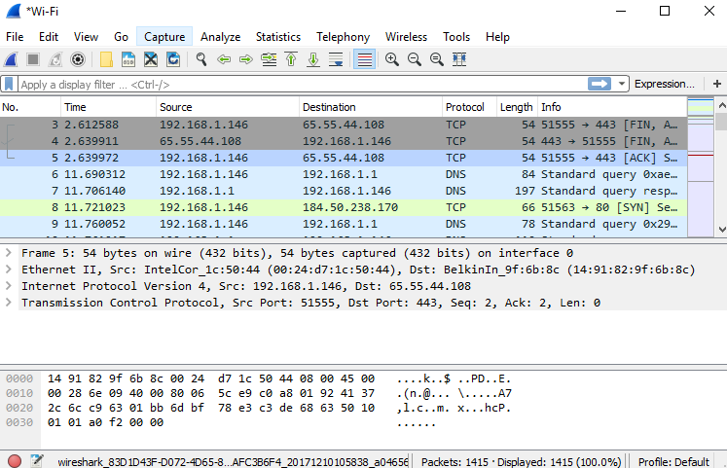

* 1. Locate appropriate packets for the web session.

If the computer was recently started and there has been no activity in accessing the internet, you can see the entire process in the captured output, including the Address Resolution Protocol (ARP), Domain Name System (DNS), and the TCP three-way handshake. If the PC already had an ARP entry for the default gateway, then it means that it started with the DNS query to resolve www.google.com.

* + 1. Frame 6 shows the DNS query from the PC to the DNS server, which is attempting to resolve the domain name www.google.com to the IP address of the web server. The PC must have the IP address before it can send the first packet to the web server.

What is the IP address of the DNS server that the computer queried? ____________________

192.168.1.1

* + 1. Frame 7 is the response from the DNS server. It contains the IP address of www.google.com.
    2. Find the appropriate packet for the start of your three-way handshake. In the example, frame 8 is the start of the TCP three-way handshake.

What is the IP address of the Google web server? __________________________________

184.50.238.170.

* + 1. If you have many packets that are unrelated to the TCP connection, it may be necessary to use the Wireshark filter tool. Type **tcp** in the filter entry area within Wireshark and press **Enter**.

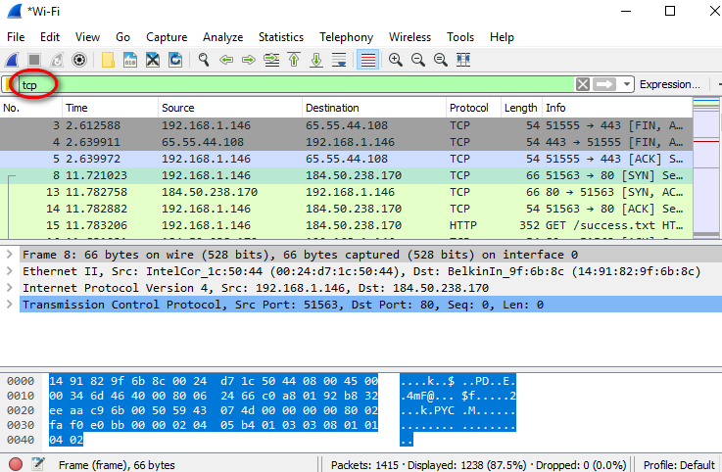

* 1. Examine the information within packets including IP addresses, TCP port numbers, and TCP control flags.
     1. In our example, frame 8 is the start of the three-way handshake between the PC and the Google web server. In the packet list pane (top section of the main window), select the frame. This highlights the line and displays the decoded information from that packet in the two lower panes. Examine the TCP information in the packet details pane (middle section of the main window).
     2. Click the **+** icon to the left of the Transmission Control Protocol in the packet details pane to expand the view of the TCP information.
     3. Click the **+** icon to the left of the Flags. Look at the source and destination ports and the flags that are set.

**Note**: You may have to adjust the top and middle windows sizes within Wireshark to display the necessary information.

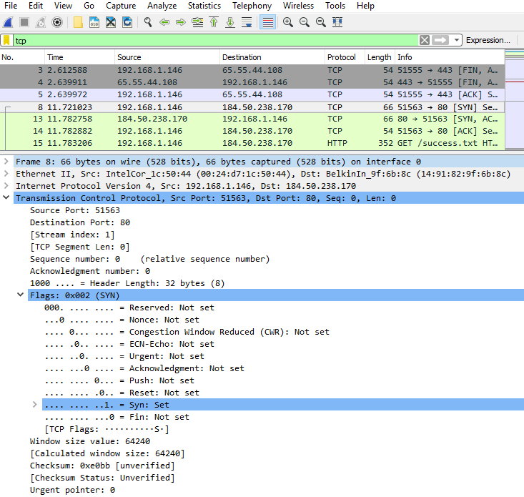

What is the TCP source port number? __________________________ 51563.

How would you classify the source port? ________________________ Dynamic or Private

What is the TCP destination port number? _______________________ Port 443

How would you classify the destination port? _____________________ Well-known, registered (HTTP or web protocol)

Which flag (or flags) is set? ________________________ SYN flag

What is the relative sequence number set to? ____________________ 0

* + 1. To select the next frame in the three-way handshake, select **Go** on the Wireshark menu and select **Next Packet in Conversation**. In this example, this is frame 13. This is the Google web server reply to the initial request to start a session.

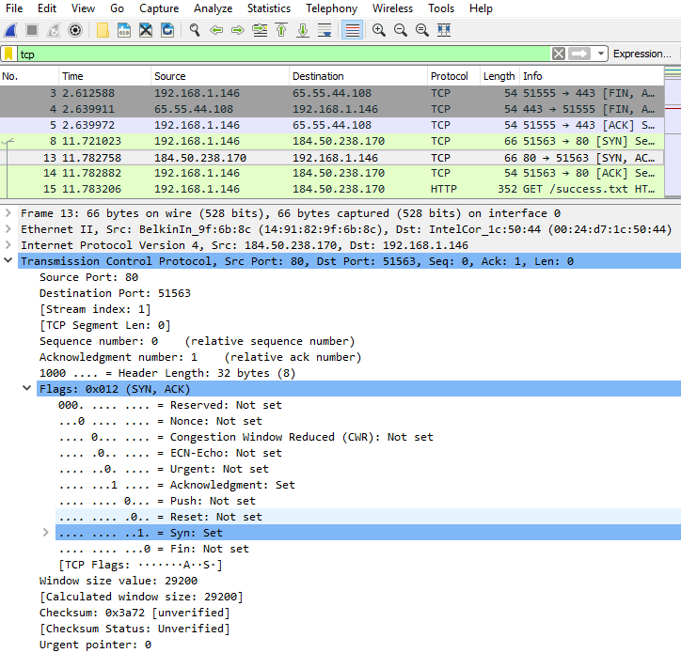

What are the values of the source and destination ports? ______________________________________

Source Port is now 80, and Destination Port is now 51563

Which flags are set? ___________________________________________________________________

The Syn flag (SYN) and Acknowledgment flag (ACK)

What are the relative sequence and acknowledgment numbers set to?

____________________________________________________________________________________

The relative sequence number is 0, and the relative acknowledgment number is 1.

* + 1. Finally, examine the third packet of the three-way handshake in the example. Click frame 14 in the top window to display the following information in this example:

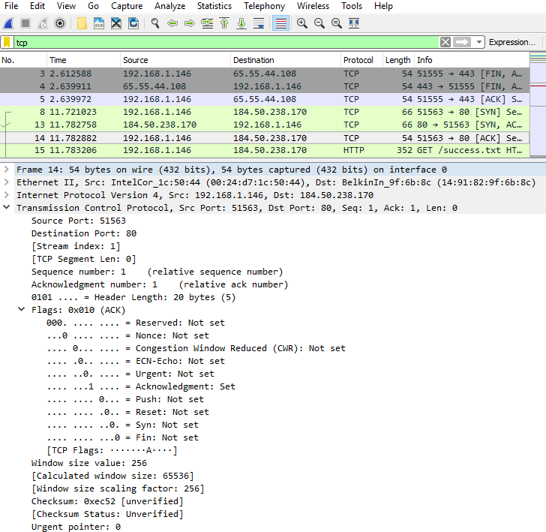

Examine the third and final packet of the handshake.

Which flag (or flags) is set? _____________________________________________________________

Acknowledgment flag (ACK)

The relative sequence and acknowledgment numbers are set to 1 as a starting point. The TCP connection is established and communication between the source computer and the web server can begin.

* + 1. Close the Wireshark program.

1. Reflection
   1. There are hundreds of filters available in Wireshark. A large network could have numerous filters and many different types of traffic. List three filters that might be useful to a network administrator?

_______________________________________________________________________________________

_______________________________________________________________________________________

_______________________________________________________________________________________

Answers will vary but could include TCP, specific IP Addresses (source or destination), and protocols such as HTTP.

* 1. What other ways could Wireshark be used in a production network?

_______________________________________________________________________________________

_______________________________________________________________________________________

_______________________________________________________________________________________

Wireshark is often used for security purposes for after-the-fact analysis of normal traffic or after a network attack. New protocols or services may need to be captured to determine what port or ports are used.